**Department of Computing**

**CS-213: Advanced Programming**

**Class: BSCS 7AB**

**Lab 08: React JS**

**Date: 07 November, 2019**

**Time: 10:00-01:00pm & 02:00-05:00pm**

**NAME: ALI ABID CHAUHDARY**

**CLASS: BSCS 7-B**

**REGISTATION NO:213292**

**Instructor: Dr. Sidra Sultana**

**Lab Engineer: Ms. Ayesha Asif**

**LAB TASKS:**

1. You have to practice the states codes covered in class lecture

**State Codes**

**CODE 1**

import React from 'react';

class Welcome extends React.Component {

constructor(){

super()

this.state={message:"welcome visitor"}

}

  render(){

  return( <h1>{this.state.message}</h1>

  )

}

}

export default Welcome;

**Output:**



**CODE 2:**

import React from 'react';

class Welcome extends React.Component {

  constructor(){

    super()

    this.state={message:"welcome visitor"}

    }

    changeMessage(){

    this.setState({

    message: "Thank you for subscribing"

    })

    }

      render(){

      return (

    <div>

    <h1>{this.state.message}</h1>

    <button onClick={()=>this.changeMessage()}>Subscribe</button>

    </div>

      )

    }

  }

export default Welcome;

**OUTPUT**

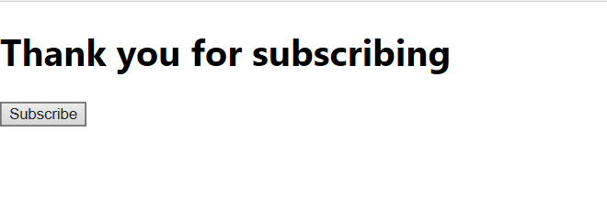

**CODE 3 COUNTER:**

import React from 'react';

class Welcome extends React.Component {

    constructor(props){

    super(props)

    this.state={ count:0} }

    Increment(){

    this.setState( {

    count:this.state.count+1})

    }

     render(){

    return (

    <div>

    <h1>Counter: {this.state.count}</h1>

    <button onClick={()=>this. Increment()}>Increment</button>

    </div> )} }

export default Welcome;

**OUTPUT:**

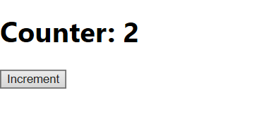

1. Create a timer application which asks the user for minutes. The user then click Start button and starts the timer count down. Preview @ <https://7zyz2y4p5j.csb.app/>

**TO RUN REPLACE YOUR App.js Code with the following:**

**CODE App.js:**

import React from 'react';

class Clock extends React.Component{

  constructor(props){

    super(props);

    this.state = {

      mins: 0,

      secs: 0,

      clicked: false

    }

    this.setTimer = this.setTimer.bind(this)

    this.runClock = this.runClock.bind(this)

    this.changeTime = this.changeTime.bind(this)

  }

  setTimer(event){

    this.setState({

      mins: event.target.value

    })

  }

  runClock(){

    if(this.state.mins >=1){

    this.setState({secs: 59, mins: this.state.mins-1, clicked:  true });

    this.intervalID = setInterval(()=>this.changeTime() ,1000);}

  }

  changeTime(){

    if(this.state.mins ===0 && this.state.secs===0)

    {

      clearInterval(this.intervalID);

    }

    else if(this.state.secs === 0 ) {

      this.setState({

        secs: 59,

        mins: this.state.mins-1 })

    }

    else this.setState({secs: this.state.secs-1 })

  }

  render(){

      if (this.state.clicked) {

        return(

    <div style = {{marginLeft:100, marginTop:30}}>

      <h1>Countdown </h1>

      <div><h1 style = {{fontSize:'80px'}}>{this.state.mins}:{this.state.secs}</h1></div>

    </div>

    )

  }else{

  return(

    <div style = {{marginLeft:100}}>

      <h2>Input your desired time </h2>

      <input type="number" onChange={this.setTimer}/><div></div>

      <div><h1 style = {{fontSize:'80px'}}>{this.state.mins}:{this.state.secs}</h1></div>

      <button style= {{marginLeft:20}}onClick={this.runClock}>Start</button>

    </div>

  )

  }

  }

}

export default Clock;

**Output:**

